**MOBILE APPLICTION DEVELOPMENT LAB**

**CYCLE 2**

1. **Create two activities. From the first activity on a button click move to the next activity.(Using intent)**

**activity_main.xml**

<**LinearLayout**

**android:layout_width="match_parent"**

**android:layout_height="match_parent"**

**android:orientation="vertical"**

**android:gravity="center"**

**xmlns:android="http://schemas.android.com/apk/res/android"**>

<**Button**

**android:layout_width="wrap_content"**

**android:layout_height="wrap_content"**

**android:text="MOVE TO NEXT ACTIVITY"**

**android:id="@+id/bt"**

**android:onClick="click"**

**android:gravity="center"**/>

</**LinearLayout**>

**MainActivity.java**

**package** com.example.sjcet.a1_activity;

**import** android.content.Intent;

**import** android.support.v7.app.AppCompatActivity;

**import** android.os.Bundle;

**import** android.view.View;

**import** android.widget.Button;

**public class** MainActivity **extends** AppCompatActivity {

Button **bt**;

@Override

**protected void** onCreate(Bundle savedInstanceState) {

**super**.onCreate(savedInstanceState);

setContentView(R.layout.***activity_main***);

**bt** = findViewById(R.id.***bt***);

}

**public void** click(View view) {

OpenNewActivity();

}

**public void** OpenNewActivity()

{

Intent intent = **new** Intent(**this**, Main3Activity.**class**);

startActivity(intent);

}

}

**activity_main3.xml**

<**LinearLayout android:layout_width="match_parent"android:layout_height="match_parent"**

**android:orientation="vertical"**

**android:gravity="center"**

**android:background="@android:color/holo_blue_light"**

**xmlns:android="http://schemas.android.com/apk/res/android"**>

<**TextView**

**android:layout_width="wrap_content"**

**android:layout_height="wrap_content"**

**android:text="WELCOME TO THE SECOND ACTIVITY"**

**android:id="@+id/tv"** />

</**LinearLayout**>

**Main3Activity.java**

**package** com.example.sjcet.a1_activity;

**import** android.support.v7.app.AppCompatActivity;

**import** android.os.Bundle;

**public class** Main3Activity **extends** AppCompatActivity {

@Override

**protected void** onCreate(Bundle savedInstanceState) {

**super**.onCreate(savedInstanceState);

setContentView(R.layout.***activity_main3***);

}

}

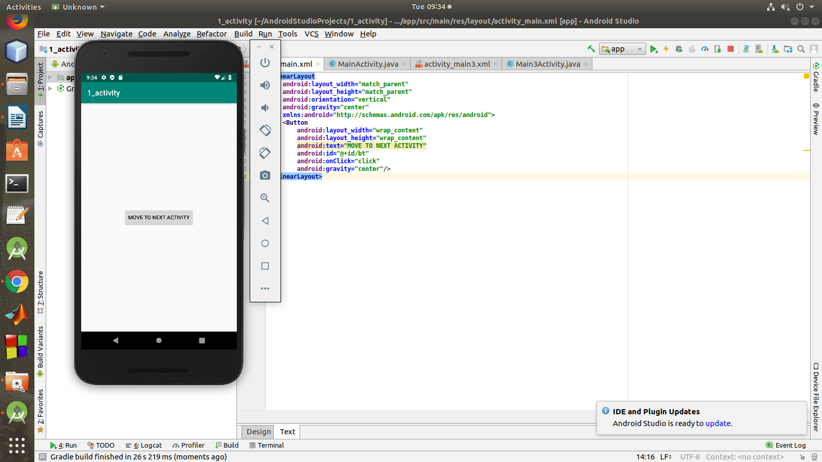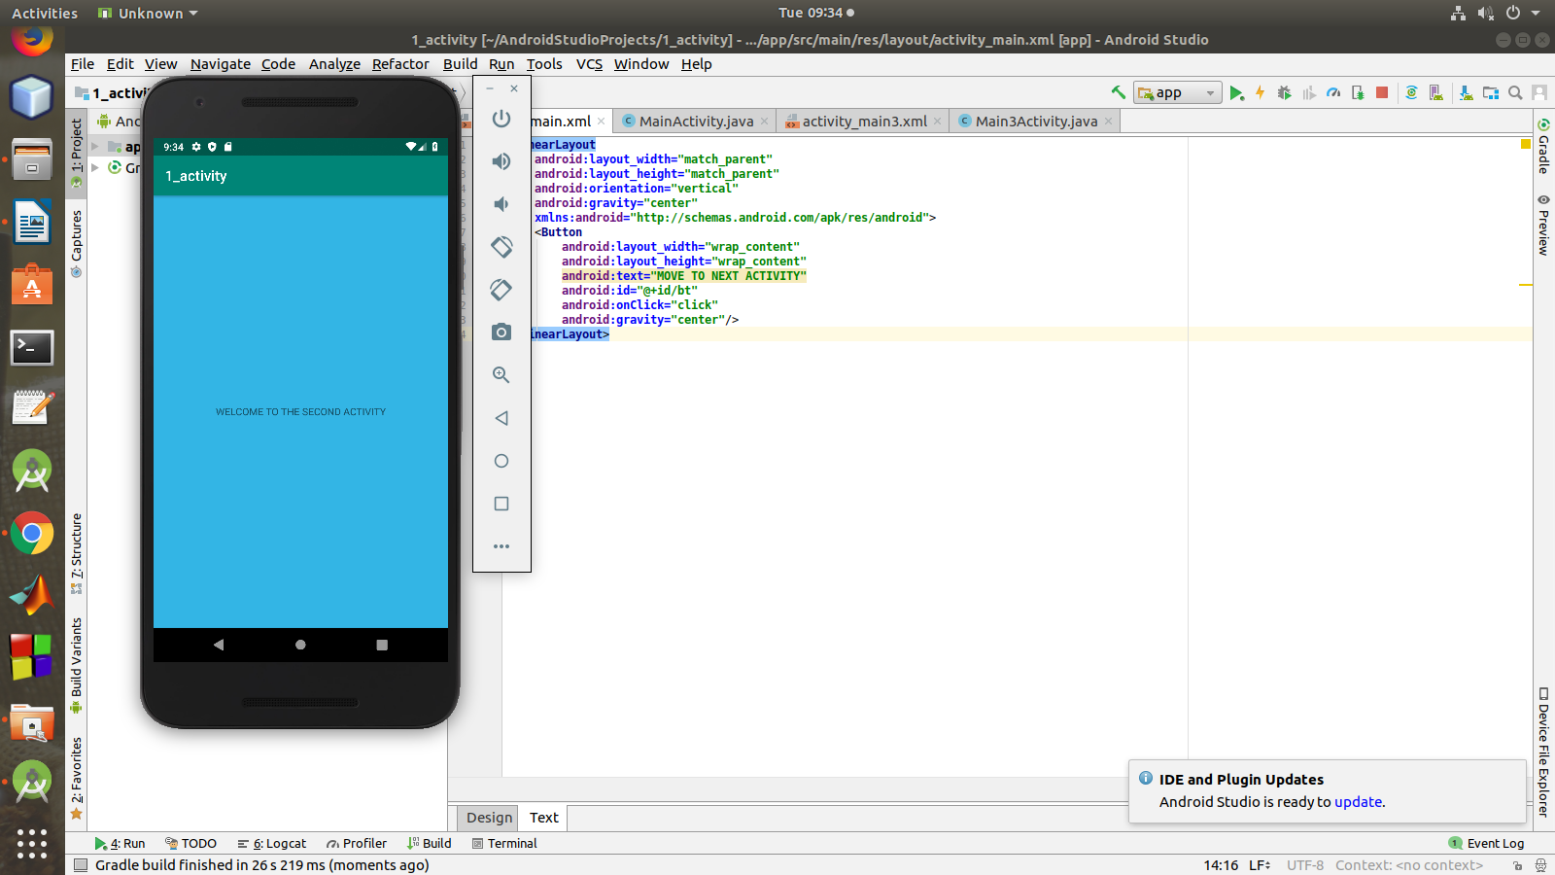

1. **Create an activity and move to the Facebook login page on a button click.(making use of intent)**

**activity_main.xml**

<**LinearLayout**

**android:layout_width="match_parent"**

**android:layout_height="match_parent"**

**android:orientation="vertical"**

**android:gravity="center"**

**xmlns:android="http://schemas.android.com/apk/res/android"**>

<**Button**

**android:layout_width="wrap_content"**

**android:layout_height="wrap_content"**

**android:text="MOVE TO FACEBOOK PAGE"**

**android:id="@+id/bt"**

**android:onClick="click"**

**android:gravity="center"**/>

</**LinearLayout>**

**MainActivity.java**

**package com.example.sjcet.a2_moveto_fb;**

**import** android.content.Intent;

**import** android.net.Uri;

**import** android.support.v7.app.AppCompatActivity;

**import** android.os.Bundle;

**import** android.view.View;

**import** android.widget.Button;

**public class** MainActivity **extends** AppCompatActivity {

@Override

**protected void** onCreate(Bundle savedInstanceState) {

**super**.onCreate(savedInstanceState);

setContentView(R.layout.***activity_main***);

Button btn_Explicit = (Button)findViewById(R.id.***bt***);

btn_Explicit.setOnClickListener(**new** View.OnClickListener() {

@Override

**public void** onClick(View v) {

Intent intent = **new** Intent(Intent.***ACTION_VIEW***,Uri.*parse*(**"https://www.facebook.com/"**));

startActivity(intent);

}

});

}

}

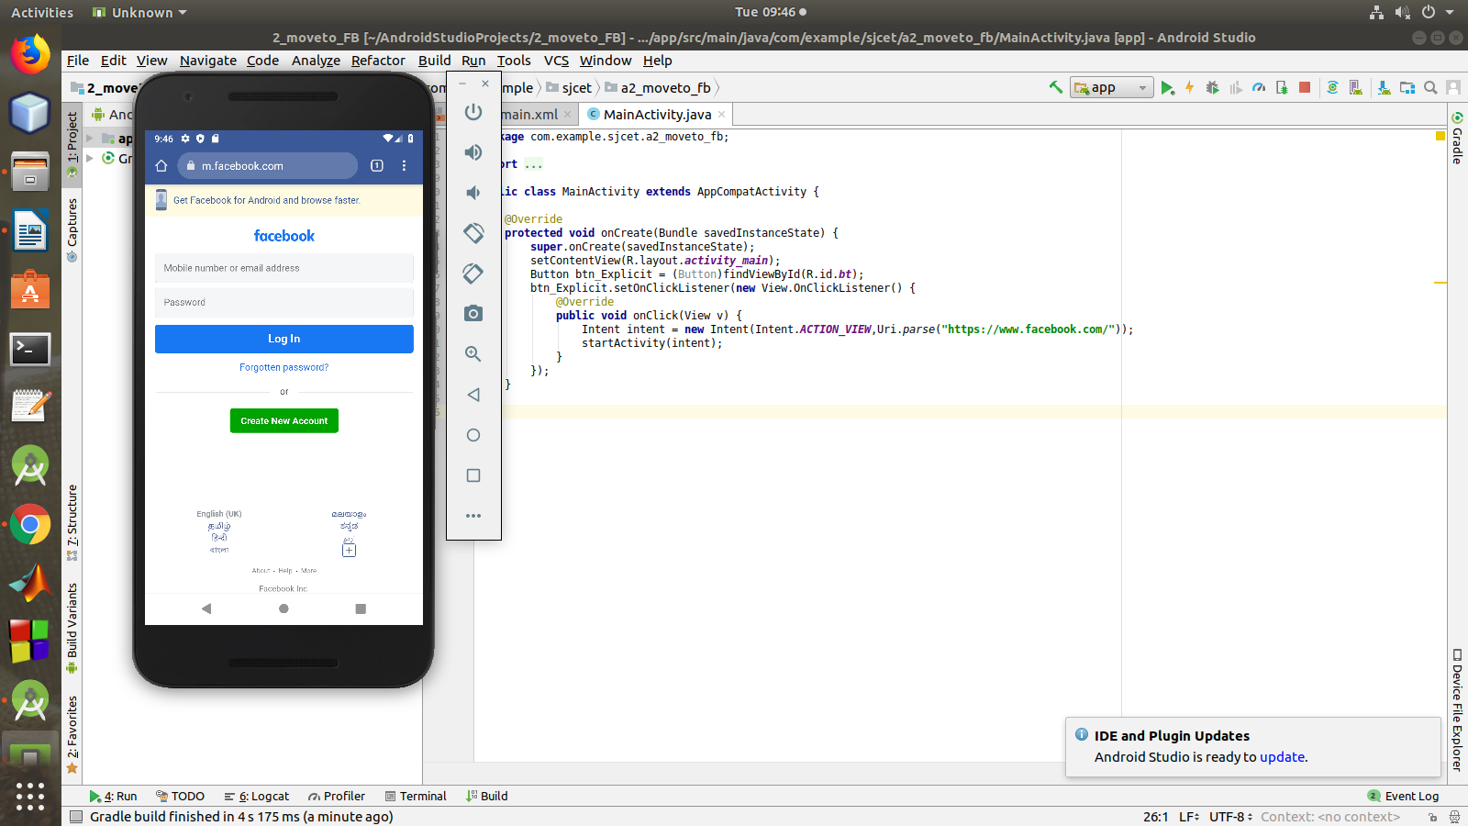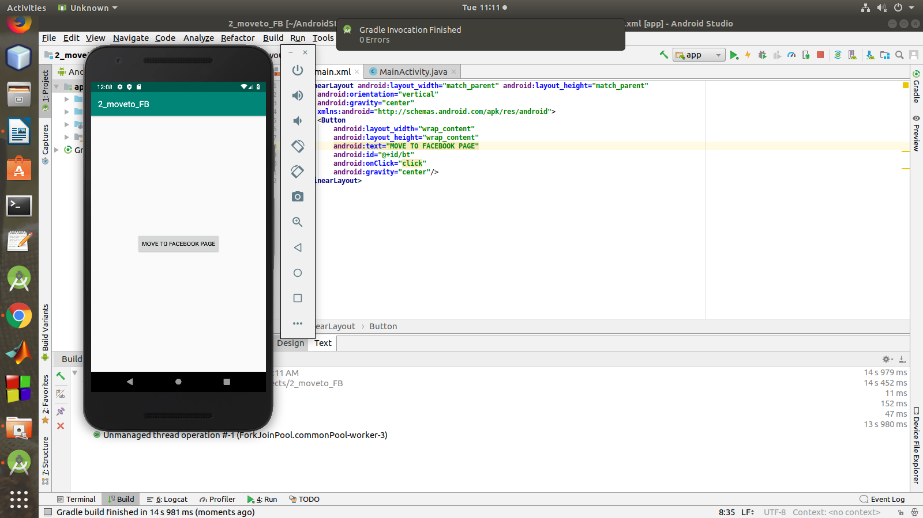

1. **Read a message in the first activity and pass it to the second activity on a button click.**

**activity_main.xml**

<**LinearLayout**

**android:layout_height="match_parent"**

**android:layout_width="match_parent"**

**android:orientation="vertical"**

**android:layout_gravity="center"**

**xmlns:android="http://schemas.android.com/apk/res/android"**>

<**EditText**

**android:layout_width="match_parent"**

**android:layout_height="wrap_content"**

**android:id="@+id/msg"**

**android:hint="Enter Message"**/>

<**Button**

**android:layout_width="wrap_content"**

**android:layout_height="wrap_content"**

**android:id="@+id/snd"**

**android:text="Send"**

**android:layout_gravity="center"**

**android:onClick="click"**/>

**</LinearLayout>**

**MainActivity.java**

**package** com.example.sjcet.a3_pass_msg;

**import** android.content.Intent;

**import** android.support.v7.app.AppCompatActivity;

**import** android.os.Bundle;

**import** android.view.View;

**import** android.widget.Button;

**import** android.widget.TextView;

**public class** MainActivity **extends** AppCompatActivity {

TextView **msg**;

Button **snd**;

@Override

**protected void** onCreate(Bundle savedInstanceState) {

**super**.onCreate(savedInstanceState);

setContentView(R.layout.***activity_main***);

**msg**=findViewById(R.id.***msg***);

**snd**=findViewById(R.id.***snd***);

}

**public void** click(View view) {

String str = **msg**.getText().toString();

Intent intent=**new** Intent(getApplicationContext(),Main2Activity.**class**);

intent.putExtra(**"Message_Key"**,str);

startActivity(intent);

}

}

**activity_main2.xml**

<**LinearLayout**

**android:layout_height="match_parent”**

**android:layout_width="match_parent"**

**android:orientation="vertical"**

**xmlns:android="http://schemas.android.com/apk/res/android"** >

<**TextView**

**android:id="@+id/rcv"**

**android:layout_width="match_parent"**

**android:layout_height="wrap_content"**

**android:gravity="center"**/>

</**LinearLayout**>

**Main2Activity.java**

**package** com.example.sjcet.a3_pass_msg;

**import** android.content.Intent;

**import** android.support.v7.app.AppCompatActivity;

**import** android.os.Bundle;

**import** android.widget.TextView;

**public class** Main2Activity **extends** AppCompatActivity {

TextView **rcv**;

@Override

**protected void** onCreate(Bundle savedInstanceState) {

**super**.onCreate(savedInstanceState);

setContentView(R.layout.***activity_main2***);

**rcv**=findViewById(R.id.***rcv***);

Intent intent=getIntent();

String str = intent.getStringExtra(**"Message_Key"**);

**rcv**.setText(str);

}

}

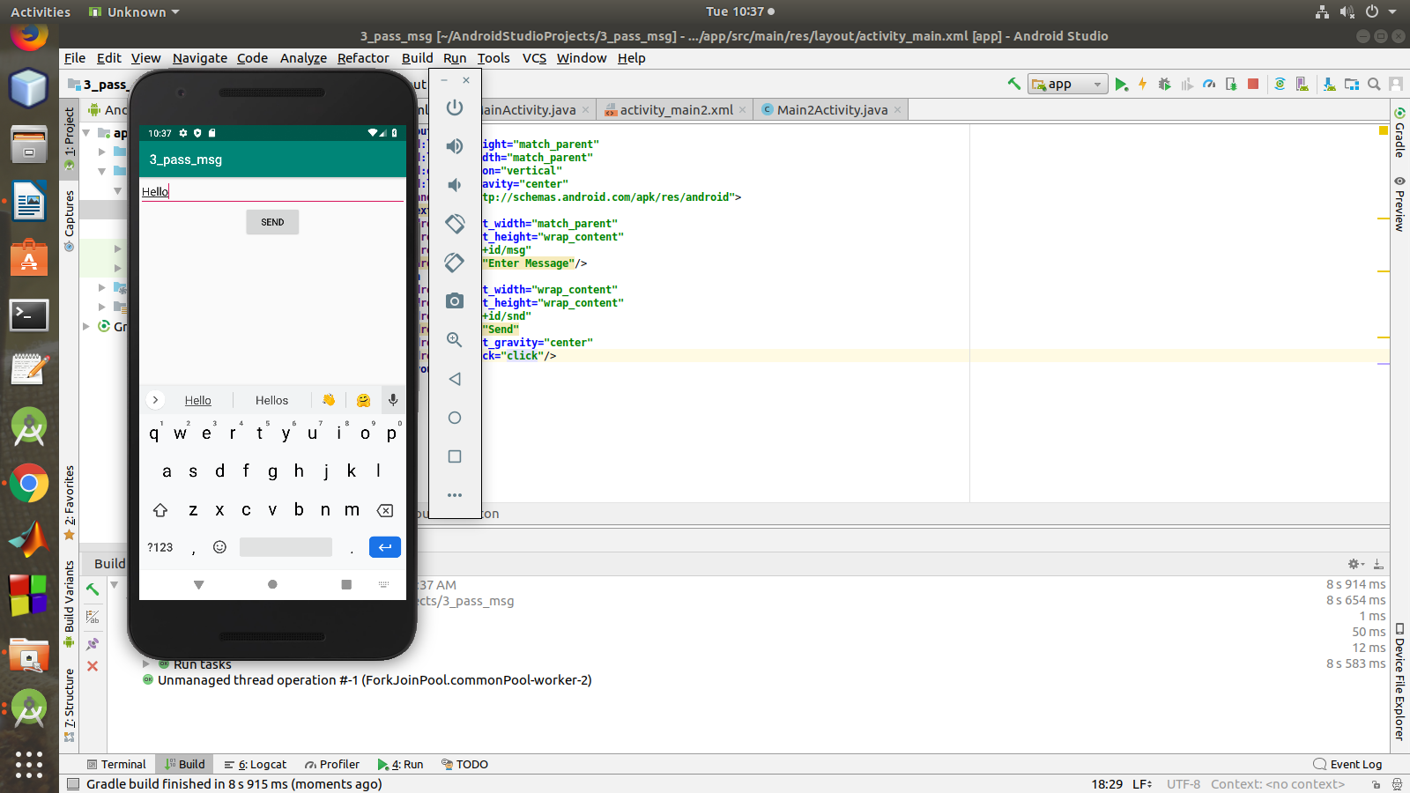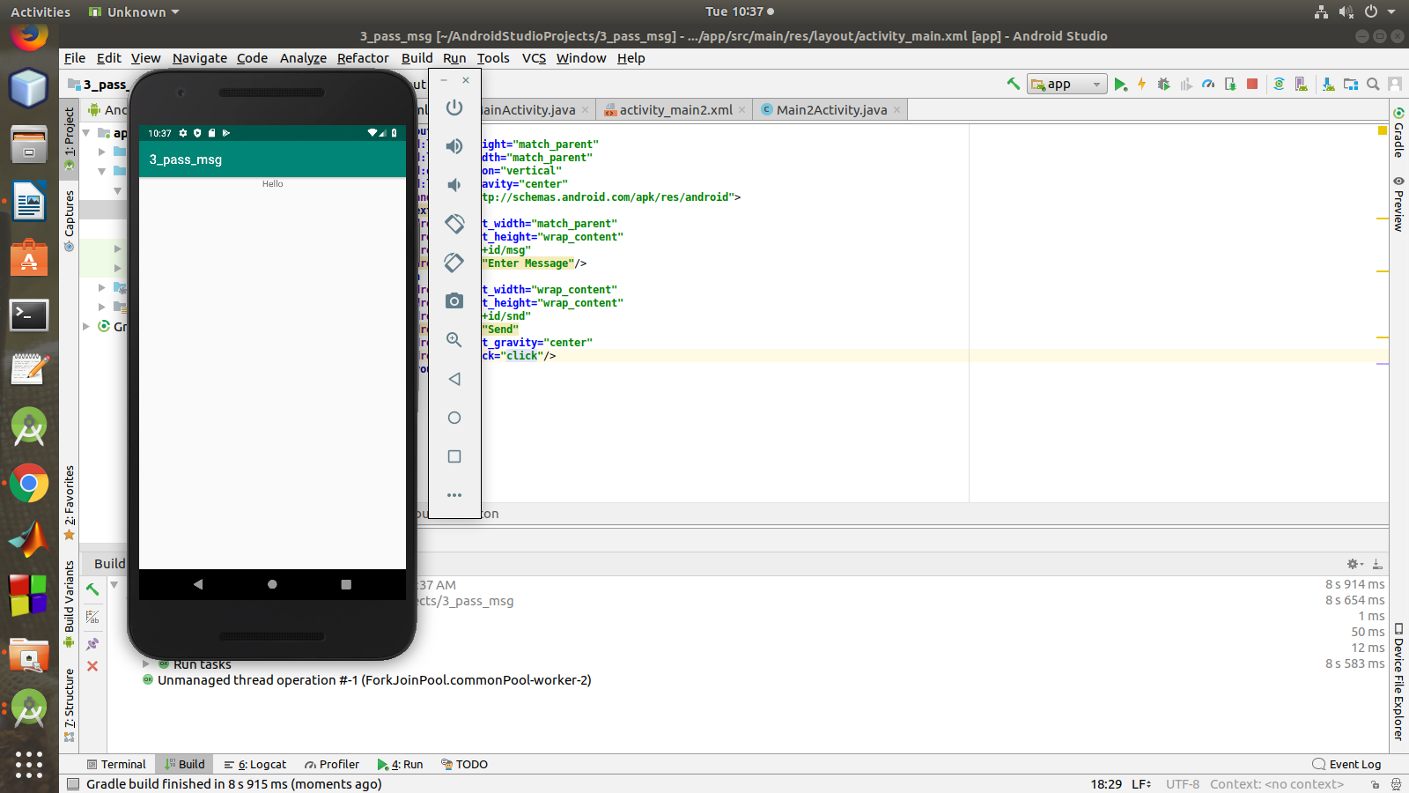

1. **Create a registration page with full validation and pass the information to the second activity (using shared preference)**

**Mandatory fields : fname,lname,gender,email,phone number,password,dob(date picker)**

**activity_main.xml**

**<LinearLayout**

**android:layout_height="match_parent"**

**android:layout_width="match_parent"**

**android:orientation="vertical"**

**android:layout_gravity="left"**

**xmlns:android="http://schemas.android.com/apk/res/android"**>

<**TextView**

**android:layout_width="match_parent"**

**android:layout_height="wrap_content"**

**android:layout_centerHorizontal="true"**

**android:layout_marginTop="32dp"**

**android:gravity="center"**

**android:text="Registration Form"**

**android:textColor="@android:color/black"**

**android:textSize="24sp"** />

<**EditText**

**android:layout_width="match_parent"**

**android:layout_height="wrap_content"**

**android:id="@+id/fname"**

**android:padding="10dp"**

**android:hint="First Name"**/>

<**EditText**

**android:layout_width="match_parent"**

**android:layout_height="wrap_content"**

**android:id="@+id/lname"**

**android:padding="10dp"**

**android:hint="Last Name"**/>

<**EditText**

**android:layout_width="match_parent"**

**android:layout_height="wrap_content"**

**android:id="@+id/gen"**

**android:padding="10dp"**

**android:hint="Gender"**/>

<**EditText**

**android:layout_width="match_parent"**

**android:layout_height="wrap_content"**

**android:id="@+id/email"**

**android:padding="10dp"**

**android:hint="Email Id"**/>

<**EditText**

**android:layout_width="match_parent"**

**android:layout_height="wrap_content"**

**android:id="@+id/phno"**

**android:padding="10dp"**

**android:hint="Contact"**/>

<**EditText**

**android:layout_width="match_parent"**

**android:layout_height="wrap_content"**

**android:id="@+id/pswd"**

**android:padding="10dp"**

**android:hint="Password"**/>

<**EditText**

**android:layout_width="match_parent"**

**android:layout_height="wrap_content"**

**android:id="@+id/dob"**

**android:padding="10dp"**

**android:hint="Date Of Birth"**/>

<**Button**

**android:layout_width="wrap_content"**

**android:layout_height="wrap_content"**

**android:id="@+id/btn"**

**android:text="Submit"**

**android:onClick="Save"**/>

</**LinearLayout**>

**MainActivity.java**

**package** com.example.sjcet.a4_registration;

**import** android.content.Context;

**import** android.content.Intent;

**import** android.content.SharedPreferences;

**import** android.support.v7.app.AppCompatActivity;

**import** android.os.Bundle;

**import** android.text.TextUtils;

**import** android.util.Patterns;

**import** android.view.View;

**import** android.widget.Button;

**import** android.widget.EditText;

**import** android.widget.Toast;

**public class** MainActivity **extends** AppCompatActivity {

EditText **fname**,**lname**,**gen**,**phno**,**email**,**pswd**,**dob**;

Button **btn**;

SharedPreferences **sharedpreferences**;

**public static final** String ***MyPREFERENCES*** = **"MyPrefs"** ;

@Override

**protected void** onCreate(Bundle savedInstanceState) {

**super**.onCreate(savedInstanceState);

setContentView(R.layout.***activity_main***);

**fname** = findViewById(R.id.***fname***);

**lname** = findViewById(R.id.***lname***);

**gen** = findViewById(R.id.***gen***);

**email** = findViewById(R.id.***email***);

**phno** = findViewById(R.id.***phno***);

**pswd** = findViewById(R.id.***pswd***);

**dob** = findViewById(R.id.***dob***);

**btn** = findViewById(R.id.***btn***);

**sharedpreferences** = getSharedPreferences(***MyPREFERENCES***, Context.***MODE_PRIVATE***);

**btn**.setOnClickListener(**new** View.OnClickListener() {

@Override

**public void** onClick(View v) {

checkDataEntered();

SharedPreferences MyPrefs = getSharedPreferences(**"activity_main2.xml"**,0);

SharedPreferences.Editor editor=MyPrefs.edit();

editor.putString(**"fname"**,**fname**.getText().toString());

editor.putString(**"lname"**,**lname**.getText().toString());

editor.putString(**"phno"**, **phno**.getText().toString());

editor.putString(**"gen"**, **gen**.getText().toString());

editor.putString(**"mail"**, **email**.getText().toString());

editor.putString(**"dob"**, **dob**.getText().toString());

editor.putString(**"pswd"**,**pswd**.getText().toString());

editor.commit();

Intent intent = **new** Intent(getApplicationContext(), Main2Activity.**class**);

intent.putExtra(**"fname"**,**fname**.getText().toString());

intent.putExtra(**"lname"**,**lname**.getText().toString());

intent.putExtra(**"phno"**, **phno**.getText().toString());

intent.putExtra(**"gen"**, **gen**.getText().toString());

intent.putExtra(**"mail"**, **email**.getText().toString());

intent.putExtra(**"dob"**, **dob**.getText().toString());

intent.putExtra(**"pswd"**,**pswd**.getText().toString());

startActivity(intent);

Toast.*makeText*(MainActivity.**this**,**"Thanks"**,Toast.***LENGTH_LONG***).show();

}

});

}

**boolean** isEmail(EditText text) {

CharSequence email = text.getText().toString();

**return** (!TextUtils.*isEmpty*(email) && Patterns.***EMAIL_ADDRESS***.matcher(email).matches());

}

**boolean** isEmpty(EditText text) {

CharSequence str = text.getText().toString();

**return** TextUtils.*isEmpty*(str);

}

**void** checkDataEntered(){

**if** (isEmpty(**fname**)) {

Toast t = Toast.*makeText*(**this**, **"You must enter first name to register!"**, Toast.***LENGTH_SHORT***);

t.show();

}

**if** (isEmpty(**lname**)) {

**lname**.setError(**"Last name is required!"**);

}

**if** (isEmpty(**phno**)) {

**phno**.setError(**"mobile number is required!"**);

}

**if** (isEmpty(**gen**)) {

**gen**.setError(**"Gender is required!"**);

}

**if** (isEmpty(**pswd**)) {

**pswd**.setError(**"Password is required!"**);

}

**if** (isEmpty(**dob**)) {

**dob**.setError(**"DOB is required!"**);

}

**if** (isEmail(**email**) == **false**) {

**email**.setError(**"Enter valid email!"**);

}

}

}

**activity_main2.xml**

**<LinearLayout android:layout_width="match_parent"**

**android:layout_height="match_parent"**

**android:orientation="vertical"**

**android:gravity="center"**

**xmlns:android="http://schemas.android.com/apk/res/android"**>

<**TextView**

**android:layout_width="wrap_content"**

**android:layout_height="wrap_content"**

**android:text="WELCOME "**

**android:textColor="@color/colorPrimaryDark"**

**android:textSize="32dp"**/>

<**TextView**

**android:layout_width="match_parent"**

**android:layout_height="wrap_content"**

**android:gravity="center"**

**android:id="@+id/tv"**

**android:textColor="@color/colorPrimaryDark"**

/>

<**TextView**

**android:id="@+id/tv1"**

**android:layout_width="match_parent"**

**android:layout_height="wrap_content"**

**android:gravity="center"**

**android:textColor="@color/colorPrimaryDark"** />

<**TextView**

**android:layout_width="match_parent"**

**android:layout_height="wrap_content"**

**android:id="@+id/tv2"**

**android:gravity="center"**

**android:textColor="@color/colorPrimaryDark"**

/>

<**TextView**

**android:layout_width="match_parent"**

**android:layout_height="wrap_content"**

**android:id="@+id/tv3"**

**android:gravity="center"**

**android:textColor="@color/colorPrimaryDark"**

/>

<**TextView**

**android:layout_width="match_parent"**

**android:layout_height="wrap_content"**

**android:id="@+id/tv4"**

**android:gravity="center"**

**android:textColor="@color/colorPrimaryDark"**

/>

<**TextView**

**android:layout_width="match_parent"**

**android:layout_height="wrap_content"**

**android:id="@+id/tv5"**

**android:gravity="center"**

**android:textColor="@color/colorPrimaryDark"**

/>

<**TextView**

**android:layout_width="match_parent"**

**android:layout_height="wrap_content"**

**android:id="@+id/tv6"**

**android:gravity="center"**

**android:textColor="@color/colorPrimaryDark"**

/>

</**LinearLayout**>

**Main2Activity.java**

**package** com.example.sjcet.a4_registration;

**import** android.content.Intent;

**import** android.content.SharedPreferences;

**import** android.support.v7.app.AppCompatActivity;

**import** android.os.Bundle;

**import** android.widget.TextView;

**public class** Main2Activity **extends** AppCompatActivity {

TextView **tv**,**tv1**,**tv2**,**tv3**,**tv4**,**tv5**,**tv6**;

@Override

**protected void** onCreate(Bundle savedInstanceState) {

**super**.onCreate(savedInstanceState);

setContentView(R.layout.***activity_main2***);

**tv** = findViewById(R.id.***tv***);

**tv1** =findViewById(R.id.***tv1***);

**tv2** =findViewById(R.id.***tv2***);

**tv3** =findViewById(R.id.***tv3***);

**tv4** =findViewById(R.id.***tv4***);

**tv5** =findViewById(R.id.***tv5***);

**tv6** =findViewById(R.id.***tv6***);

Intent intent = getIntent();

SharedPreferences mypref=getSharedPreferences(**"activity_main2.xml"**,0);

String str = mypref.getString(**"fname"**,**null**);

String str1 = mypref.getString(**"lname"**,**null**);

String str2 = mypref.getString(**"gen"**,**null**);

String str3 = mypref.getString(**"phno"**,**null**);

String str4 = mypref.getString(**"pwd"**,**null**);

String str5 = mypref.getString(**"email"**,**null**);

String str6 = mypref.getString(**"dob"**,**null**);

**tv**.setText(str);

**tv1**.setText(str1);

**tv2**.setText(str2);

**tv3**.setText(str3);

**tv4**.setText(str4);

**tv5**.setText(str5);

**tv6**.setText(str6);

}

}

